Superior endurance and reliability across industrial applications

[Watch Video](https://www.kingston.com/en/video/play?videoId=4f5VN4rf-iv0sL3SKMY-JYJ3HV2UHLcCYoj7ynGrwh0Wg9rdXOnzcDNVeU_VzzSZJXUnFx5baFx_UBYuXn5W_A2&start=0&autoPlay=False&chromeless=False&captionOption=No)

SDCIT2

* [Intro](https://www.kingston.com/en/memory-cards/industrial-grade-microsd-uhs-i-u3#product-features)
* [Specifications](https://www.kingston.com/en/memory-cards/industrial-grade-microsd-uhs-i-u3#specifications)
* [Product Comparison](https://www.kingston.com/en/memory-cards/industrial-grade-microsd-uhs-i-u3#comparison-chart-1)
* [Resources](https://www.kingston.com/en/memory-cards/industrial-grade-microsd-uhs-i-u3#links)
* [Datasheet](https://www.kingston.com/datasheets/sdcit2_us.pdf)

[**Buy**](https://www.kingston.com/en/memory-cards/industrial-grade-microsd-uhs-i-u3#atc)

Industrial microSD Memory CardIdeal for Extreme Conditions

Kingston’s Industrial microSD card is designed and tested to withstand the most demanding environmental factors. With an operating temperature of -40°C to 85°C, it can operate normally even in extreme desert heat to below freezing conditions. The card utilizes industry-leading pSLC mode to provide top transfer speeds up to 100MB/s read and 80MB/s write1. It is rated up to 1920 TBW2 with 30K P/E cycles and a built-in feature set specific to endurance, performance, and industrial needs. Kingston’s Industrial microSD ships with a UHS-I SD adapter and is available in capacities from 8GB-64GB3.

* Durable in Extreme Temperatures
* High Endurance
* UHS-I Speed Class U3, V30, A1
* Industrial Grade Built-In Features

Key Features



Durable in extreme temperatures

Designed and tested to withstand temperature range of -40°C to 85°C for use in harsh conditions

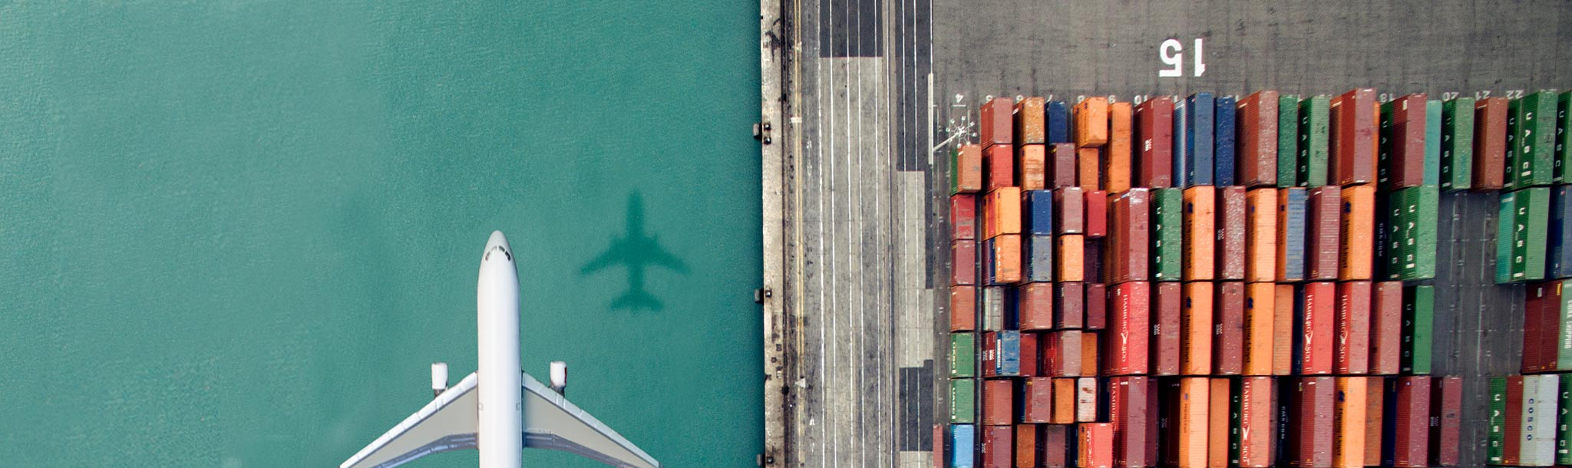

High endurance and reliability

Up to 1920 TBW2 and rated to endure 30K P/E cycles to meet requirements for a wide range of industrial applications

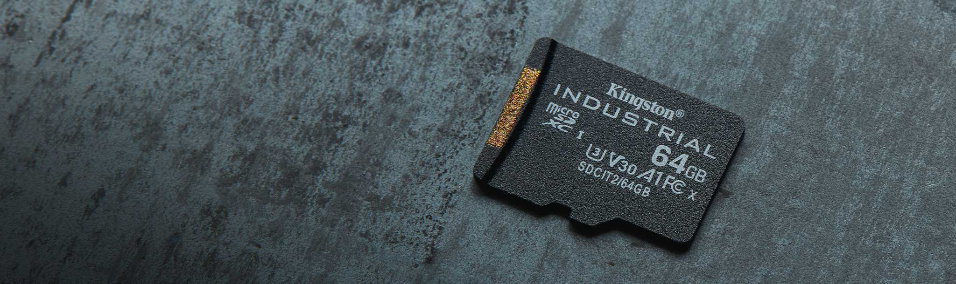

UHS-I compliant

Read/write speeds up to 100/80MB/s1 with U3, V30, and A1 support for Android based applications



Industrial grade built-in features

Strong ECC engine, Wear Leveling, Bad Block management and an optional health monitoring tool to manage the lifespan of your card4

Compare microSD Cards

SDCS2

SDCG3

SDCE

SDCIT2



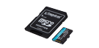

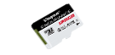

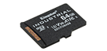

Name

Canvas Select Plus microSD

Canvas Go! Plus microSD

High-Endurance microSD

Industrial microSD

User

Consumer

Consumer

Consumer

Business/ Industrial

Capacity

64GB–512GB

64GB-1TB

32GB–256GB

8GB–64GB

Speed

100MB/s Read (64GB-128GB)  
100MB/s Read, 85MB/s Write (256GB-512GB)

•170MB/s read, 70MB/s write (64GB)  
•170MB/s read, 90MB/s write (128GB-1TB)

95MB/s Read, 30MB/s Write (32GB-64GB)  
95/MB/s Read, 45MB/s Write (128GB-256GB)

Up to 100MB/s Read, 80MB/s Write

Compatibility

UHS-I, U1, V10, A1 (64GB-128GB) UHS-I, U3, V30, A1 (256GB-512GB)

UHS-I, U3, V30, A2

UHS-I, U1, V10, A1

UHS-I Speed Class U3, V30, A1

Usage

• Point and shoot cameras  
• Android devices

• 4K Video Production  
• Action Cameras  
• Drones  
• Android Devices

• Dash cameras  
• Security cameras  
• Body cameras

• Designed and tested to be durable in extreme temperatures

[Learn more](https://www.kingston.com/en/memory-cards/canvas-select-plus-microsd-card)

[Learn more](https://www.kingston.com/en/memory-cards/canvas-go-plus-microsd-card)

[Learn more](https://www.kingston.com/en/memory-cards/high-endurance-microsd-card)

[Learn more](https://www.kingston.com/en/memory-cards/industrial-grade-microsd-uhs-i-u3)

 Reset Chart

 Remove

 Remove

 Remove

 Remove

* [Industrial microSD](javascript:void(0))

Capacity

 8GB

 16GB

 32GB

 64GB

Adapter

 SD Adapter

 None

* Part Number: SDCIT2/8GB
* microSDHC/SDXC Industrial Card
* Includes SD adapter
* 3-year warranty

[**Where to Buy**](https://www.kingston.com/en/wheretobuy)

Specifications

|  |  |
| --- | --- |
| Capacities3 | 8GB, 16GB, 32GB, 64GB |
| Speed1 | Up to 100MB/s read, 80MB/s write |
| Performance1 | Class 10, UHS-I, U3, V30, A1 |
| Endurance2 | Up to 1920 TBW 30K P/E cycles |
| NAND | TLC in pSLC mode |
| microSDHC Card Dimensions | 11mm x 15mm x 1mm |
| SD Adapter Dimensions | 24mm x 32mm x 2.1mm |
| Format | FAT32 for SDHC and ExFAT for SDXC |
| Operating & Storage Temperature | -40°C to 85°C |
| Voltage | 3.3V |
| Industrial Features | • Bad Block Management • Strong ECC Engine • Power Failure Protection • Wear Leveling • Auto-Refresh Read Distribution Protection • Dynamic Data Refresh • SiP – System in Package • Garbage Collection • Health Monitoring |
| Durability | Waterproof5 Temperature proof6 Protected from airport x-rays7 |
| Thermal Cycle Testing | Interval testing completed at various extreme temperatures |
| Vigorous Temperature Humidity Bias | Several hundred hours of testing to ensure durability at varying levels of humidity |
| Wide Temp Chamber Testing | Completed on all SDCIT2 cards prior to production |
| Warranty4 | 3 years |